Chapter 14, Solution 25.

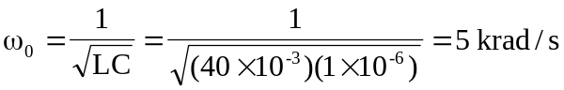

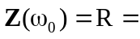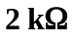
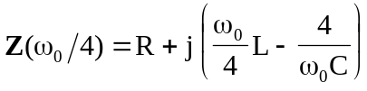
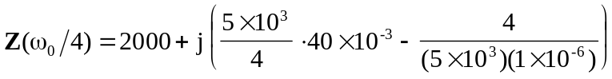

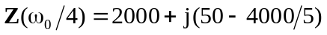

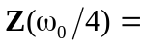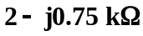

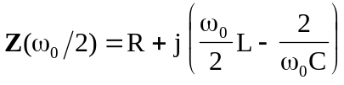

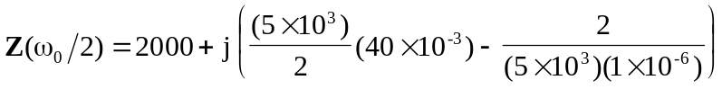

Z(ω₀/2) = 200+j(100-2000/5)

